

***DAT 32403 WEB PROGRAMMING HATTA & HALIM***

|  |  |
| --- | --- |
| **LAB 2**  **BASIC OF PHP, VARIABLES AND DATA TYPES** | |
| **COURSE CODE** | **DAT 21303** |
| **COURSE NAME** | **WEB DEVELOPMENT** |
| **FACULTY** | **CENTRE OF DIPLOMA STUDIES (CeDS) DEPARTMENT OF INFORMATION TECHNOLOGY** |
| **STUDENT NAME** | **QAIREL QAYYUM BIN MUHAMAD RIDHUAN (AA212363)** |
| **SECTION** | **6** |
| **LECTURER NAME** | **MISS.NADIA** |
| **SUBMIT DATE** | **31 OCTOBER 2022** |

**Question 1:** Complete the Table 1.0 below with the right theoretical knowledge and apply in PHP atmosphere. In row 1st are the example how it can be made.

|  |  |  |  |
| --- | --- | --- | --- |
| **No** | **Instruction** | **Theoretical Explanation** | **Code Segmentation** |
| 1. | Print the output using variable namely $city.  The output is “pagoh jaya” | $city is a variable which is allocated memory by computer. It keeps “pagoh jaya” as a string and can be printed by using echo  function | <!DOCTYPE html>  <html>  <body>  <?php  $city = 'pagoh jaya!';  echo $city;  echo "<br>";  ?>  </body>  </html> |
| 2. | Declare three variables of integer, string and float. Prove how PHP determine the data type from declared variables. | Write $ followed by variable name that start with a letter to all variable declaration. PHP determined by the type of the value that was assigned  to that variable. | <!DOCTYPE html>  <html>  <body>  <?php  $postalCodes = 62208;  $city = "pagoh jaya";  $valuePi = 3.14  ?>  </body>  </html> |
| 3. | var_dump() is a function in PHP. Show how it can be utilized for integer, string and float? | var_dump() is a function that return data type. When use it in integer and float it will return the data type and value while in string it will return the data type, value and number of letters value. | <!DOCTYPE html>  <html>  <body>  <?php  $qaiAge = 19;  echo var_dump($qaiAge) . "<br>";  $city = "Pagoh Jaya!";  echo var_dump($city) . "<br>";  $qaiHeight = 175.7;  echo var_dump($qaiHeight) . "<br>";  $mada = array("nur", "madarina", "syafiah");  echo var_dump($mada) . "<br>";  $mix = array(19, "Pagoh Jaya!", 175.5, array("nur", "madarina", "syafiah"));  echo var_dump($mix) . "<br>";  // Dump two variables  echo var_dump($qaiAge, $qaiHeight) . "<br>";  ?>  </body>  </html> |
| 4. | Global and local scope is so  important. How to use it? | Global is used to access global variable within function and declare it before function. While local is used to particular function and declare it in the function. | <!DOCTYPE html>  <html>  <body>  <!DOCTYPE html>  <html>  <body>  <?php  function location() {  $city = "pagoh"; // local scope  $postalCode= 6228;  echo "<p>$city postcode is: $postalCode </p>";  }  location();  // using x outside the function will generate an error  echo "<p>$city postcode is: $postalCode”</p>";  ?>  </body>  </html>  </body>  </html> |
| 5. | $love = “we love pagoh” using php function in string library calculate  the word from $love | Using function str_word_count() in string library which calculate  length of string. | <!DOCTYPE html>  <html>  <body>  <?php  $str="We love Pagoh";  echo str_word_count($str). " count of words <br/>";  echo strlen($str). "number of characters <br/>";  ?>  </body>  </html> |
| 6. | How to use define in PHP? | When using a constant to define a value that will not change. | <!DOCTYPE html>  <html>  <body>  <?php  define("GREETING","Hello you! How are you today?");  echo constant("GREETING");  ?>  </body>  </html> |

<!--1.Print the output using variable namely $city.

The output is “pagoh jaya”-->

<!DOCTYPE html>

<html>

<body>

<?php

$city = 'pagoh jaya!';

echo $city;

echo "<br>";

?>

</body>

</html>

<!--2.Declare three variables of integer, string and float.

Prove how PHP determine the data type from declared variables.”-->

<!DOCTYPE html>

<html>

<body>

<?php

$postalCodes = 62208;

$city = "pagoh jaya";

$valuePi = 3.14

?>

</body>

</html>

<!--3.var_dump() is a function in PHP. Show how it

can be utilized for integer, string and float?-->

<!DOCTYPE html>

<html>

<body>

<?php

$qaiAge = 19;

echo var_dump($qaiAge) . "<br>";

$city = "Pagoh Jaya!";

echo var_dump($city) . "<br>";

$qaiHeight = 175.7;

echo var_dump($qaiHeight) . "<br>";

$mada = array("nur", "madarina", "syafiah");

echo var_dump($mada) . "<br>";

$mix = array(19, "Pagoh Jaya!", 175.5, array("nur", "madarina", "syafiah"));

echo var_dump($mix) . "<br>";

// Dump two variables

echo var_dump($qaiAge, $qaiHeight) . "<br>";

?>

</body>

</html>

<!--4.Global and local scope is so

important. How to use it?-->

<!DOCTYPE html>

<html>

<body>

<!DOCTYPE html>

<html>

<body>

<?php

function location() {

$city = "pagoh"; // local scope

$postalCode= 6228;

echo "<p>$city postcode is: $postalCode </p>";

}

location();

// using x outside the function will generate an error

echo "<p>$city postcode is: $postalCode”</p>";

?>

</body>

</html>

</body>

</html>

<!--5.$love = “we love pagoh” using php

function in string library calculate

the word from $love-->

<!DOCTYPE html>

<html>

<body>

<?php

$str="We love Pagoh";

echo str_word_count($str). " count of words <br/>";

echo strlen($str). "number of characters <br/>";

?>

</body>

</html>

<!--6.How to use define in PHP?-->

<!DOCTYPE html>

<html>

<body>

<?php

define("GREETING","Hello you! How are you today?");

echo constant("GREETING");

?>

</body>

</html>

**Question 2: Using HTML create a registration form based on Table 1.1.**

<!DOCTYPE html>

<html>

<body>

<h2>HTML Forms</h2>

<form method="post" action="pageone.php" action="<?php echo $_SERVER['PHP_SELF'];?>"> <!--$_SERVER is a PHP super global variable which

holds information about headers,

paths, and script locations.-->

<label for="name">Your name:</label><br>

<input type="text" id="name" name="name" required/><br><br>

<strong><?php //PHP $_POST is a PHP super global variable which is used to

//collect form data after submitting an HTML form with

//method="post". $_POST is also widely used to pass variables

// the post method sends information via http headers

//The <strong> tag is used to define text with strong importance.

//The content inside is typically displayed in bold

if ($_SERVER["REQUEST_METHOD"] == "POST") { //saya declare id untuk username as

//username dengan fungsi ini syntax post akan mengembalikan input yg dimasukkan earlier as username apabila id bersamaan kosong input validation akan keluar username is empty

// collect value of input field

$name = $_POST['name'];

if (empty($name)) {

echo "name is empty";

} else {

echo $_POST['name'];

}

}

?></strong>

<label for="email">Your e-mail:</label><br>

<input type="text" id="email" name="email" required/><br><br>

<strong><?php

if ($_SERVER["REQUEST_METHOD"] == "POST"){

// collect value of input field

$id= $_POST['email'];

if (empty($id)) {

echo "email is empty";

} else {

echo $id;

}

}

?></strong>

<input type="password" id="psw" placeholder="password"

pattern="(?=.*\d)(?=.*[a-z])(?=.*[A-Z]).{8,}"

title="Must contain at least one number and one

uppercase and lowercase letter, and at least 8 or more characters" required/><br/><br/>

<strong><?php

if ($_SERVER["REQUEST_METHOD"] == "POST"){

// collect value of input field

$id= $_POST['psw'];

if (empty($id)) {

echo "password is empty";

} else {

echo $id;

}

}

?></strong>

<br>Message<br>

<textarea name="message" rows="10" cols="30"></textarea> <!--The <textarea> tag defines a multi-line text input control.

The <textarea> element is often used in a form, to collect user

inputs like comments or reviews.

A text area can hold an unlimited number of characters, and the

text renders in a fixed-width font (usually Courier).

The size of a text area is specified by the cols and rows

attributes (or with CSS).

-->

<br><br>

<input type="submit" value="Submit">

<input type="button" value="Clear">

<br><br>Additional options: <br>

<input type="checkbox" id="country1" name="country1" value="USA">

<label for="USA">USA</label><br>

<input type="checkbox" id="country2" name="country2" value="Canada">

<label for="Canada"> Canada</label><br>

<input type="checkbox" id="country3" name="country3" value="Mexico">

<label for="Mexico"> Mexico</label><br>

<br>Do you agree?

<input type="radio" id="yes" name="choice" value="Yes">

  <label for="yes">Yes</label>

  <input type="radio" id="no" name="choice" value="No">

  <label for="no">No</label><br>

<br><label for="language">Select an item from the dropdown :</label>

<select id="language" name="language">

<option value="PHP">PHP</option>

<option value="HTML">HTML</option>

<option value="JS">JS</option>

<option value="CSS">CSS</option>

</select>

<br><br>

</form>

</body>

</html>

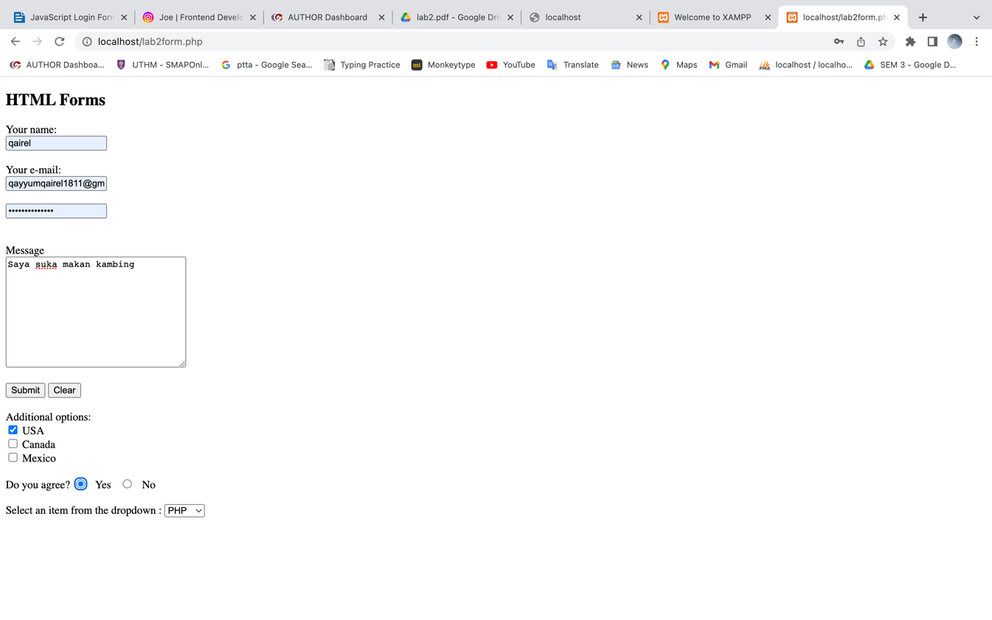

<!DOCTYPE html>

<html lang = "en">

<head>

<meta charset="utf-8">

<title>Make a comment</title>

</head>

<body>

<h1>Make a comment</h1>

<p>

Thank you for your participation!

We have registered your comment in our database :

</p>

<u1>

<li> NAME :

<strong><?php echo $_POST['name']; ?></strong>

</li>

<li> EMAIL :

<strong><?php echo $_POST['email']; ?></strong>

</li>

<li> COMMENT :

<strong><?php echo $_POST['message']; ?></strong>

</li>

</u1>

</body>

</html>

**A variable is a container to store a value of data, it can have short name or meaningful name but there will be a rules while naming the variable. Firstly, it is compulsory start with $ sign then followed with variable name, must start with a letter or underscore; cannot start with a number.**

**However, the variable names can be alphanumeric but only contains (A-z, 0-9 and _).The values assigned to a PHP variable may be of different data types including simple string and numeric types to more complex data types like arrays and objects.**

**PHP supports total eight primitive data types: Integer, Floating point number or Float, String, Booleans, Array, Object, resource and NULL. These data types are used to construct variables.**

**Based on this work, PHP can be written anywhere in document then HTML result is sent back to the browser. In PHP, all variable names is case sensitive. Besides, there are two ways to declare a variable. It can be a local and global scopes. A global variable is declared outside a function while a local variables is declared inside the function. Also, a variable can be a constant where the value of a constant cannot be change for the whole program and the syntax is different. You can declare a constant in PHP by using define function.**